

**Project**

By Roi Bokobza



roibokobza017@gmail.com



**Project introduction:**

This project provides a brief introduction to Linux and Bash, starting with the basics and progressively covering more advanced scripting concepts.

We'll begin by learning how to create and run our first Bash script while building a strong foundation in scripting.

Throughout the project, I will complete 20 tasks using Ubuntu OS on Oracle VM. Each task will include a detailed explanation, step-by-step instructions, and screenshots to help you learn as you follow along.

Words in **this** color are clickable hyperlinks (Ctrl + left click)

Below this page there is a clickable table of content for this project.

**Table of Contents (Clickable)**

Introduction to Linux ----------------------------------------------- 4

Introduction to Bash ----------------------------------------------- 8

Bash scripting ------------------------------------------------------ 13

Task 1 Directory management --------------------------------- 22

Task 2 User management -------------------------------------- 26

Task 3 Permissions ----------------------------------------------- 36

Task 4 Creating groups ------------------------------------------ 42

Task 5 – 6 Modify groups --------------------------------------- 45

Task 7 – 10 File management/sort --------------------------- 49

Task 11 – 12 Soft-Link and cleanup -------------------------- 66

Task 13 Downloading packages ------------------------------ 71

Task 14 – 16 Networking files and config ------------------- 73

**What is Linux?**

Linux is a free, open-source operating system created by Linus Torvalds in 1991, designed to be customizable and secure. Unlike Windows or macOS, Linux gives users full control, allowing them to modify the system to their liking. It's known for its stability, security, and performance; thus, it is the more popular OS (operating system) amongst developers, tech enthusiasts, and even companies like Google and NASA.  
The best part? Linux is free and has a global community constantly improving it.  
If you love flexibility and privacy, Linux is your playground.



**Why should we use Linux?**

Linux computers are quite common in enterprise environments due to their cost-effective and open-source nature, Linux also reduces hardware requirements and provides stability and security, with regular updates and strong user permissions.  
The Linux interface is a color-coded command line that uses bash commands, with many commands allowing for a variety of actions to be performed on a system.  
Linux commands are straightforward and often use common English words that relate directly to their functions, making them easier to understand and use.

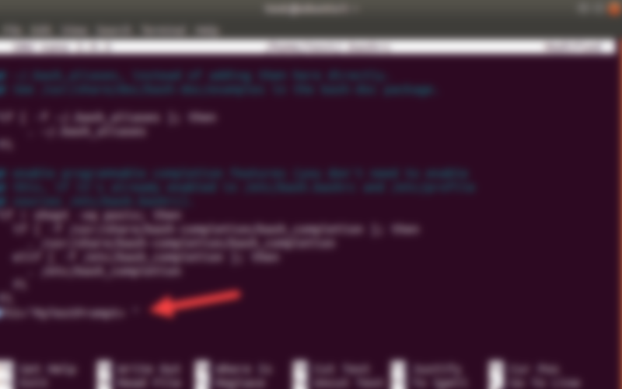

**Benefits of Linux:**

**Security** – Due to its open-source nature, developers can quickly identify and fix security issues.   
Linux’s simple bash commands work to its advantage, making patching swift and efficient.   
Additionally, Linux is less prone to viruses and malware than other operating systems, further strengthening its security.

**Stability** - Linux hardly ever crashes or freezes, making it great for long-running tasks. That’s why it’s the choice for servers and critical systems—it can run for weeks, months, or even years without needing a reboot

**Performance** - Linux requires fewer system resources, making it ideal for older hardware and efficient for demanding applications.

**Open source** –Linux's open–source nature allows for more customization and personalization while allowing its developer community to thrive. The code is out there for anyone to learn and improve without restrictions.

**It's free!** – Linux is free to use, eliminating the need for expensive licensing fees, which makes it an affordable option for both individuals and businesses.

 **How do we boot Linux?**

To run Linux on any operating system, we use a Virtual Machine (VM). A VM can be thought of as a 'virtual computer' that utilizes the power and memory of the physical machine, creating an isolated environment to run a different OS. This allows us to run Linux alongside other systems. For this project, I’ve used Oracle VM and installed the Ubuntu ISO on my machine.

For a more detailed guide, check out [**the full instructions on systems and virtual machines on my LinkedIn**](https://www.linkedin.com/posts/roi-bokobza-1163b0314_full-active-directory-server-management-activity-7244307525221720064-sZTd?utm_source=share&utm_medium=member_desktop).

**What can we do with Bash?**

Before diving into chaining commands and writing Bash scripts, it's essential to understand the fundamentals. What are the core commands and basic functions that form the foundation of Bash scripting?

**Command execution** – At its core, Bash is all about running commands, whether built-in (like cd, echo, ls) or external programs (vim, ping, curl). Bash gives direct orders to your system.

**File & Directory Management –** Create, move, delete, and change files and folders through a command line with commands like *mkdir (make directory), rm (Remove), cp (copy)*, and *mv* (move or rename).   
The commands in Bash are intuitive and closely resemble everyday language, making it easy to execute actions like creating, moving, copying, and deleting files and directories.

**Process Management** – Bash lets you manage programs running on your system. For example, you can:

* View running processes with *ps* or *top*.
* Stop a process with *kill* (if it's unresponsive).
* Run commands in the background using   
  *longcommand &*

**Scripting & Automation –** Instead of manually typing the same commands repeatedly, you can write them in a Bash script *'sh file*' and execute them.   
This is useful for automating tasks like backups, updates, or deployments*.*

**User & Permission Control –** Linux is a multi-user system, so Bash provides ways to manage access rights:

* *chmod* – Changes file permissions (who can read, write, or execute).
* *chown* – Changes file ownership.
* *su / sudo* – Switch users or execute commands as an administrator.

**Text Processing –** Bash provides powerful tools to search, filter, and modify text data:

* *grep* – Searches for text in files.
* *awk* – Processes and formats text.
* *sed* – Edits text within files.
* *cut* – Extract specific sections of text.

I'll go into each of these commands in detail in the following tasks.

**KEEP IN MIND: Linux is Case-sensitive!  
Linux will treat upper and lower-case letters differently**

**Terminal Overview:**

The command UI for Linux is called "Shell", Shell holds the system commands that we can execute on our machine.

There are many different types of "Shell" Command lines, the most common one and the one we will use is called "Bash" and the software that runs Shell is called "Terminal".

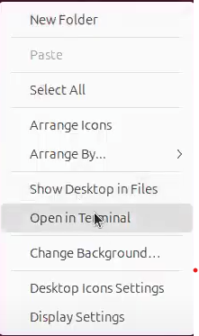To open the Terminal, Right-click on the desktop of the virtual machine > open in Terminal. This should open the Linux Command line.

When opening the Terminal the first we'll notice is a command line that features a **DNS name**, This name is the user's name, and the name that comes after "@" is the **domain name**. **'~/Desktop'** stands for the directory we are currently on. This **"$"** symbol indicates a regular (non-root) user is using the shell.



**Updating / upgrading Linux:**

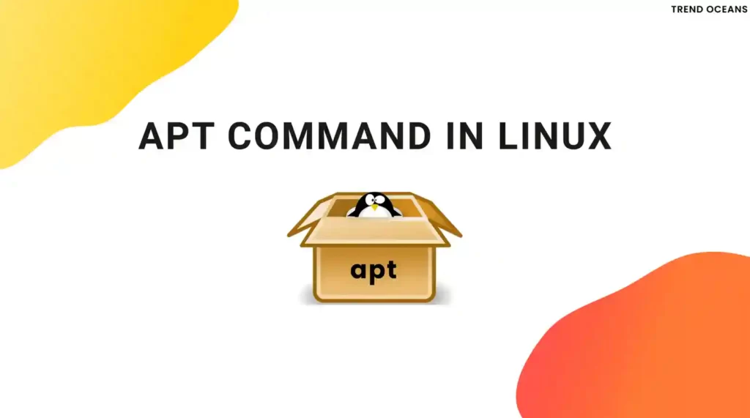Keeping your Linux system up-to-date is incredibly easy, thanks to **Bash** and the apt package manager. Here’s how it works in two simple steps:

**Upgrade:**

* Your system contacts the **software repositories** (The servers where Linux is stored).
* It checks for the latest versions of all the programs you have installed.
* It updates the local list of available software but doesn’t download or install anything yet.

'sudo apt upgrade'

To upgrade your repositories simply type this command into bash.

**Update:**

* Your system **compares** the updated list of software with what’s currently installed.
* It downloads and installs the latest versions of all the programs you have.
* The -y flag automatically says "yes" to any prompts, making the process seamless.

'sudo apt update -y

**Sudo – Super user do**

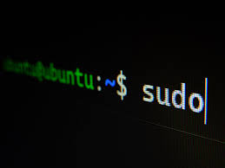sudo (which stands for **"superuser do"**) is a command that lets you run other commands with **superuser (root) privileges**.   
In Linux, some tasks like installing software, changing system files, or adjusting permissions need higher-level access.   
sudo gives you that access temporarily, letting you bypass the usual restrictions for regular users.

**Key Points:**

**Security First –** sudo ensures that only authorized users can make important changes to the system.

**Control:** It’s a way to perform admin tasks without logging in as the root user, which is safer and more manageable.

**Audit Trail:** Every command run with sudo is logged, meaning you can track who, what, and when a command was executed.

**Bash scripting:**

To dive straight into Linux, let's start with a simple script (yes, already!).  
here is a very simple script that can be written in seconds;

Let's type *'nano helloworld.sh'* in the terminal*,* The nano command opens a text editor.

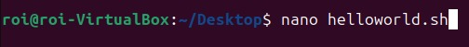

and we’re creating a **new file** named *helloworld.sh*. The *.sh* extension stands for *"shell script,"* indicating that this file will contain Bash commands.

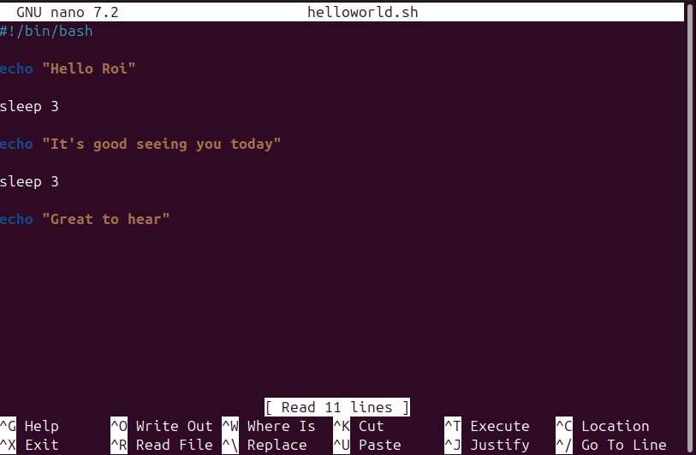

Before we start scripting, the first thing to include is *#!/bin/bash* at the top of the file this tells the system to use the Bash shell to execute the script, it is called **Shebang!**

Next, we use the *echo* command followed by a message in quotes to display text on the screen.   
To introduce a delay between commands, we add *sleep*, followed by the number of seconds we want the script to pause.   
Once everything is written, we exit the editor by pressing **Ctrl + X**, confirm saving by pressing **Y**, and finalize it by hitting **Enter**.

Now to execute we'll type *'bash helloworld.sh',* now we typed *'bash'* which is the script execute the command, then *"<script file name>".*

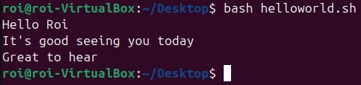

When you type bash *'helloworld.sh'*, you're telling the system to run the script using the **Bash** shell.

* ***bash*** is the command that starts the Bash interpreter.
* ***helloworld.sh*** is the script file name, which contains the commands to be executed.

The file can also be executed by typing *'./helloworld.sh'*, the problem is we don't have execute authority, so let's change it.

**Check permissions –** Before adding permissions let's take a look at what permissions we do have for our "helloworld.sh" file. When typing *'ls -l <filename>.sh'*, the command will list all Permissions, represented by   
*"-rw-rw-r—"*.  
r = read, w = write, and the letter missing here is x which stands for execute, but here it's marked by "-", meaning the execute permission is missing.



**Add execute authority** – Adding executions is simple, simply type *"****chmod +x <filename>.sh****"*. this command does what it sounds like, change mode > add x (execute) to this file (helloworld.sh).

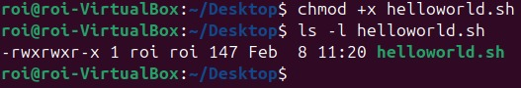

I then type *'ls -l helloworld'* and the execute permission is now added (rwx, read + write + execute).  
**Run command –** Let's run the script by typing ./helloworld.sh  
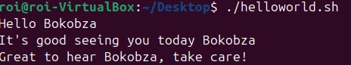

**Variables:**

Variables

Arguments

More variables

To add some flare to our scripts we'll use variables.  
A variable in Linux is a named storage location that holds a value, which can be used and modified within scripts or the shell.

Here is a simple example of a variable, we'll now tell the script "helloworld" to greet the name it is given.

In nano helloworld.sh, add an echo command under shebang (#!/bin/bash), asking the user for his name,   
*'echo "What is your name"*' under this line type   
'read name'. This command prompts the user to enter their name and stores it in the variable; name. In simple terms, we told Bash to take the user's input and store it in a variable called name. This shows how clear and easy-to-understand Bash scripting can be.

Now we should specify where this value is going to be used in the script, I replaced my name with '$name', $ represents a variable, and 'name' is the name we chose for this variable, this should tell the script "say hello and then use the value that was given to you".

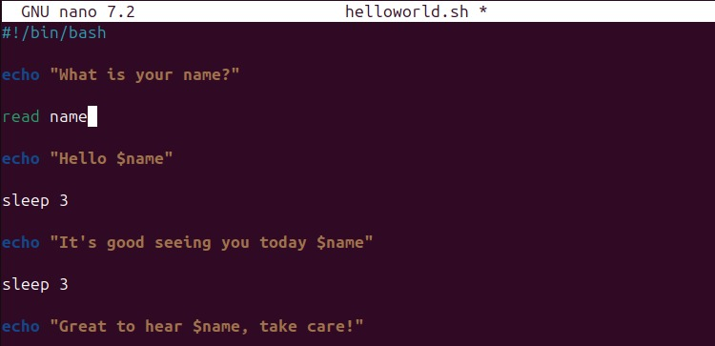

To save press Ctrl + x, Y, and Enter.

Let's run the script, *'./helloworld.sh',* The script now asked me for a name, I typed Eliot, Eliot is now stored in the variable $name and is used throughout the script.

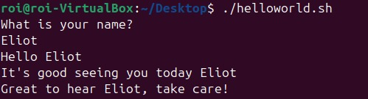

**Arguments:**

it's now time to put scripts into practice! Let's automate a process using scripts to assist a company or office efficiently using Arguments.

Variables

Arguments

More variables

As shown in the prior explanation, we'll type *"nano <script name>.sh",* A text box now opened, before we type anything we must start with a **Shebang!** (#!/bin/bash).

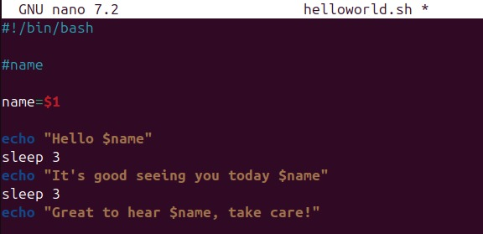

Here all I did was type '*name=$1'* and let the script run its course; ('#name' is just a label for identifying the script).

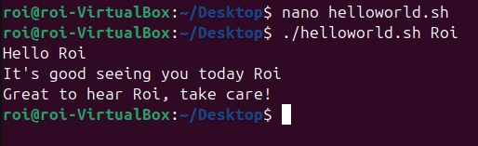

I executed helloworld but after it typed 'Roi' and got greeted by the name I typed.

**What does 1$ stand for?** The $ digit represents the "positional parameter", whatever parameter we put after ./helloworld.sh will be the **first** parameter, and what we put after that will be the second parameter represented by '$2', and so on.

Here is an example:  
I once again edited the script (nano) to add a second positional parameter, this one will be stored under a variable I called "drink", the script will now ask for two variables, your name ($1) and your drink ($2).

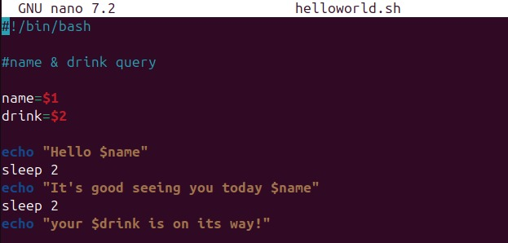

I instructed the script to use the **$drink** variable on the final line.

I typed **'*./helloworld.sh Roi Coffe'*** to give it a try:  
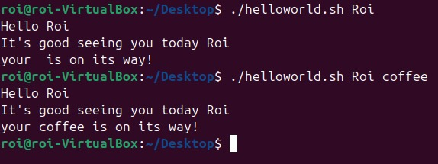

I told the script to use Roi as the first positional perimeter and Coffee as the second, now 'Roi' is stored under $name and 'Coffee' is stored under $drink.

**More variables:**

Now let's make this script more informative, I added commands like, whoami, pwd, and

Variables

Arguments

More variables

**whoami** – Shows the current logged-in user.

**pwd** – Displays the current directory path.

**date** – Prints the current date and time date under variables.

I typed these commands into these variables by typing "<variable-name>=$('command')"

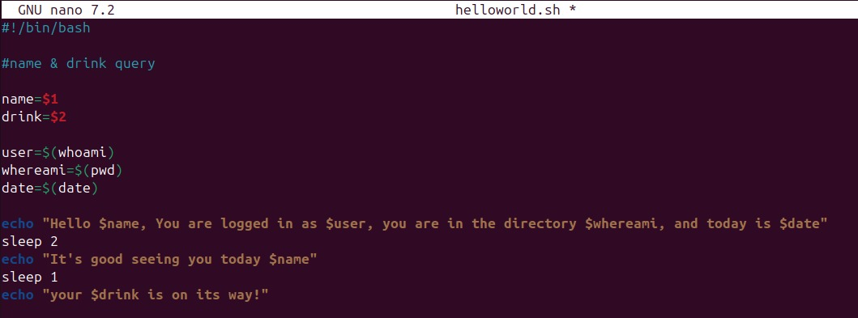

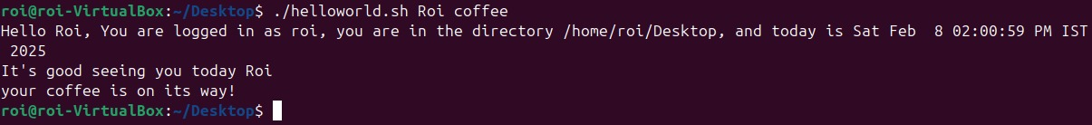I then integrated these variables into the greeting line, which now displays the logged-in user, current directory, and today's date.

A very simple and effective script.

**Task 1: Directory management.**

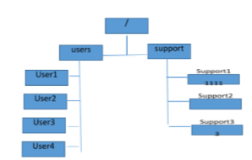

For this task it is required of me to create 2 directories under the root directory (/), one named 'users' and the other 'support', then create 4 directories under users and 3 more under support.

The first command, *'cd /'*, moves me to the root folder, represented by */*.

Initially, I was on the Desktop ***(~/Desktop)***, but after typing *cd /*, I moved to the root directory, as shown in the **second line.**

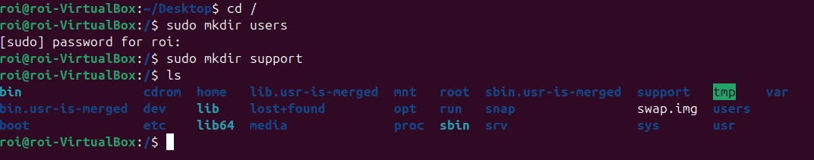

inside of root I typed 'sudo mkdir users', here is a breakdown:  
**sudo** – Stands for "SuperUser Do". It runs the command with administrative (root) privileges, allowing you to perform tasks that require higher permissions.

**Mkdir** – Stands for "make directory". It creates a new directory (folder).

**Users** – The name of the directory you're creating. In this case, it creates a folder called users.  


To gain sudo permissions, I'll be prompted **to enter my password** and press Enter. After that, I typed **'sudo mkdir support'** to create the second folder. Finally, I used the **'ls'** command, which lists all directories within the current directory.  
Here I can see both folders under root marked in **orange**

Now, to create folders within the "users" directory, I’ll use the 'cd users' command to navigate into it.   
Then, using **'sudo mkdir'**, I’ll create multiple folders at once: user1, user2, user3, and user4.   
**After entering my password**, I’ll type **'ls'**, and I can see all **4 directories** were successfully created under "users"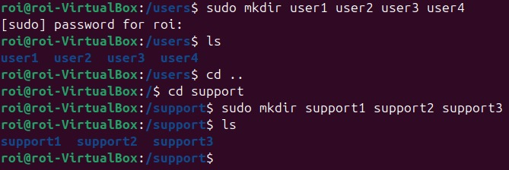  
Now, I’ll do the same with the "support" directory.   
I type **'cd ..'** to move up one level, bringing me to the root. I went back to the root folder to access the support folder from there.   
Next, I navigate to "support" by typing ***'cd support'*.**   
Now, inside the "support" directory, I use 'sudo mkdir' to create three directories: support1, support2, and support3. After typing ***'ls'*** to check, I can see all **three directories** have been created successfully.

This is what our directory tree now looks like and we have completed the task successfully.

**Skills learned: mkdir, sudo, cd, ls, chmod, permissions.**

**Task 2: Users management**

Create 3 users with the following settings:

* Assign the password miko123 for each account
* Create a home directory under the directory 'Users'
* For users 1 and 2 set the shell to /bin/bash
* Set the account for user2 to expire on 30/08/22
* For user1 set the account to require a password change every 45 days with a minimum of 5 days
* Set up user4 without a home directory and without a shell, add a comment "system account."

**Create 3 users:**

Create 3 users

Sub-task 1

Sub-task 2

Sub-task 3

Sub-task 4

Sub-task 5

Sub-task 6

Enter the command *'sudo useradd <username>'* and add all 3 individually *(sudo useradd user1, sudo useradd user2 and so on).*

Another way to create all three users and the preferable way is by chaining them together with && like this.

**'sudo useradd -m user1 && sudo useradd -m user2 && sudo useradd -m user3'.**

The extension -m creates a home directory.

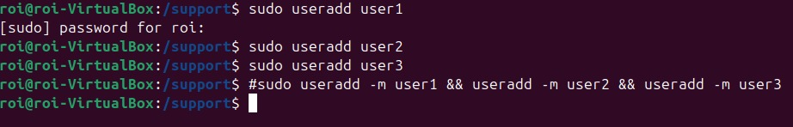

Ensure the users exist by typing *'id <username>*' I typed all id's in a chained command.  
The id command will display the user’s ID, group ID, and any additional groups they belong to, confirming their existence.

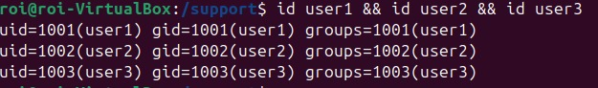

**Assign a password to each account:**

Command:  
*'echo "user1:miko123" | sudo chpasswd'* here is how I changed the password for user1, here is a breakdown.

Create 3 users

Sub-task 1

Sub-task 2

Sub-task 3

Sub-task 4

Sub-task 5

Sub-task 6

echo "user1:miko123" outputs the text "user1:miko123" to the terminal.

| (pipe) sends that output to the next command.

sudo chpasswd reads the input from the pipe and assigns the password to the user.



Now, I will log into user1 by entering the command   
'su - user1', which switches the user to user1. It will ask for the password, and while the password is correct, I am unable to access the terminal because user1 does not yet have a home folder.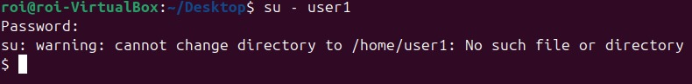

Now that it works, I will assign the password for the rest of the accounts using && to chain the commands together.

Notice how I used **sudo** twice. The reason is that I’m piping one command into a second command. Since the second command is standalone and requires elevated permissions to modify user settings, it also needs **sudo** to execute properly.



**Create a home directory under the Directory users:**

Create 3 users

Sub-task 1

Sub-task 2

Sub-task 3

Sub-task 4

Sub-task 5

Sub-task 6

Before moving the users, I will type the command *'cat /etc/passwd'*. This will display the user information stored in the passwd file, including each user's home directory.

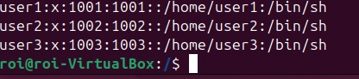  
Command: *'sudo* ***usermod -d*** */users/user1 user1'* let's break it down:

Usermod: This command is used to modify user account properties. The -d flag specifically allows us to change the user's home directory.

-d /users/user1: This sets the home directory of user1 to /users/user1.

user1: This specifies which user account we are modifying.

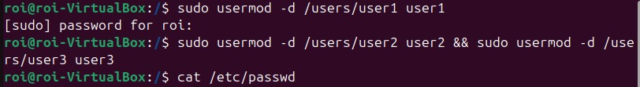

After entering the password for sudo permissions, I used a chained (&&) command to move the rest of the users.

Finally, I confirmed the results typing ***'cat /etc/passwd'***

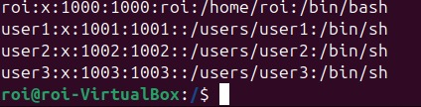

All users were successfully moved to their designated directory.

**Set shell /bin/bash to users 1 and 2:**

Use the usermod command with the -s option to set the shell.

Type: *'sudo usermod -s /bin/bash user1 && sudo usermod -s /bin/bash user2'*

**

Create 3 users

Sub-task 1

Sub-task 2

Sub-task 3

Sub-task 4

Sub-task 5

Sub-task 6

**usermod** is used to modify an existing user’s properties. The **-s** option sets the user’s default shell.

**-s /bin/bash** changes the default shell to /bin/bash for the **specified user**.

**Verify the command:**

The command: '*cat /etc/passwd | grep "user1\|user2"*'  
This will display the entries for user1 and user2, confirming their assigned shells.



**Verify explanation:**

'*cat /etc/passwd | grep "user1\|user2"*'

cat /etc/passwd – Displays the contents of the '/etc/passwd' file, which stores user account details.

| (Pipe) Passes the output of cat /etc/passwd to the next command (grep).

grep "user1\|user2" grep works as a filtering command and shows only the lines containing "user1" or "user2".

The \| acts as an OR operator, meaning it will match either "user1" or "user2" and display their details.

**Set the account for user2 to expire on 30/08/22:**

Create 3 users

Sub-task 1

Sub-task 2

Sub-task 3

Sub-task 4

Sub-task 5

Sub-task 6

Command: *'sudo chage -E 2022-08-30 user2'*.

The chage command is used to set expiration policies for an account.

-E this is a flag that specifies the expiration date in the format: YYYY-MM-DD, I set the date to 2022-08-30.

And finally specify the user you want to apply the date to

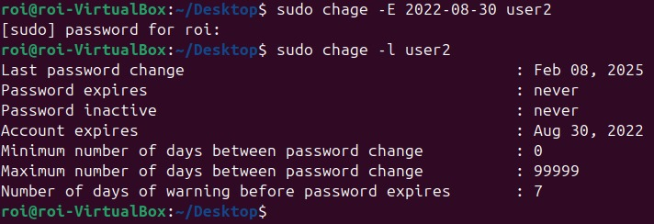

**Verify:**

Type 'sudo chage -l user2', this command will display the details of the account specified (user2). **The expiration date is now set to 2022-08-30**, among password expiration dates, minimum / maximum number of days between password change, date of the last password change, etc.

The -l flag in the chage command stands for "list"

**Set the account 'user1' to require a password change every 45 days with a minimum of 5 days:**

Create 3 users

Sub-task 1

Sub-task 2

Sub-task 3

Sub-task 4

Sub-task 5

Sub-task 6

We'll user 'chage' once again for expiration policies under a different flag. The command goes like this:

' sudo chage -M 45 -m 5 user1'

chage -M 45: Sets the maximum number of days before the password must be changed to 45. Specified by a capital M

chage -m 5: Sets the minimum number of days before the password can be changed to 5. Specified by a lowercase m.

**Verify:**

Let's display the chage list for user1 again by typing   
*'sudo chage -l user1'*

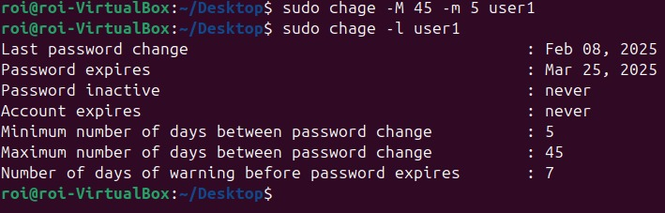

The properties of the user are now updated with the correct **amount of days**.

**Set up user4 without a home directory and without a shell, add a comment "system account."**

Create 3 users

Sub-task 1

Sub-task 2

Sub-task 3

Sub-task 4

Sub-task 5

Sub-task 6

I typed the command: '*sudo useradd -M -s /usr/sbin/nologin -c "system account" user4.*

**-M –** Prevents the creation of a home directory for user4.

-s /usr/sbin/nologin – Sets the shell to nologin, meaning the user cannot log in interactively (have a shell session).

-c "system account" – Adds a comment to user4's account for clarification.

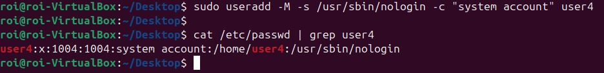

**Verify:**

As we can see in the picture above, I typed '*cat /etc/passwd | grep user4'.*

cat /etc/passwd – Displays user account details.

| (Pipe) – pipes the output to the grep command for filtering.

grep user4 – Filters the output to show only user4's details.

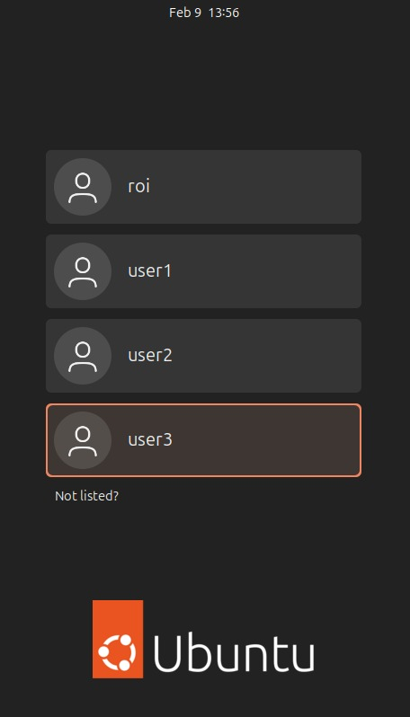We can see the user now updated to **nologin** along with our comment **"system account"**.

And finally, Verify the existence of the users we've created throughout the GUI (Graphical user interface):

**Skills learned:** sudo, useradd, passwd, usermod, mv, chage, cat, grep, pipe

**Task 3: Permissions Deep-dive.**

**Basics of Permissions:** Before solving these tasks, we must truly understand how permissions work in linux. every file and directory in Linux has permissions that determine who can do what with it. These are broken down into:

* **Owner** (u) – The user who owns the file.
* **Group** (g) – Users in the same group as the owner.
* **Others** (o) – Everyone else.

We can grant three types of permissions to each one:

* **r (read)** – Can view the contents.
* **w (write)** – Can modify the file or create/delete inside a directory
* **x (execute)** – Can run the file as a program.

To view permissions use 'ls -l"

>>>

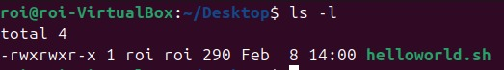

Here are my permissions as a root user they are displayed inside the **red square**, let's break it down.

-rwxrwxr-x

The way permissions are structured are   
"(file or directory)(Owner)(Group)(Others)", in this order

'-' The first character, '-' stands for a **file**, 'd' stands for a **directory**.

* rwx – read write execute permissions for the Owner (u)
* rwx – read write execute permissions for Group (g)
* r-x – read execute permissions for Others (o)

**Permission numeric values:**

* r = 4
* w = 2
* x -1
* = 0

You **sum** them up to get a permission number.  
For example, **775** means:

* 7 (Owner: 4+2+1 = rwx)
* 5 (Group: 4+2+1 = rwx)
* 5 (Others: 4+0+1 = r-x)

This is called UMASK value.

**Set the default permissions for newly created files so that:**

* Owner (user) has rwx (read, write, execute)
* Group has rw- (read, write)
* Others have --x (execute only)

Calculate the appropriate UMASK value, the permission values equal to 761, 7 for owner (all permissions 4+2+1), 6 for group (read write 4+2+0), 1 for others (0+0+1).

Since we want new files to have rwxrw--x (761), the UMASK should be: 777 - 761 = 016, to calculate UMASK value **for directories**, The appropriate UMASK is 016.

* Why 016? Because by subtracting 761 from 777 we get rid of the permissions we don’t want, (execute in group (1), read and write (6) in others).

**Set UMASK:**

One way to load our UMASK value to a file is by typing:

* *'umask 016'* New directories will have rwxrw--x (761)
* *'echo "umask 016" >> ~/.bashrc'* To keep this setting after reboot, add this line too.   
  *'source ~/.bashrc'* source reads and **executes** the commands inside a file **without needing to restart the shell.** 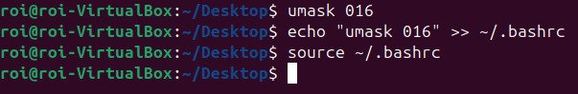

I set my UMASK value, then echoed my UMASK value using **">>"** which appends the **output** of a command **to a file**, in this case, adding the umask setting to '~/.bashrc'.

**What is 'bashrc'?**  
it is the configuration file for the Bash shell which runs every time the system is booting up, meaning my value will be stored in there an won't be reset when rebooting.



**Source:**

The third and final line, **Source Reads** and **executes** the commands inside a file without needing to restart the shell. >>

Instead of logging out and back in, source makes the changes apply immediately, I then specified the file which I want to apply the changes to.

* Changing UMASK could also be done manually using 'nano', *'sudo nano ~/.bashrc'*, this will grant you access to the contents of the file where you can edit the value manually.

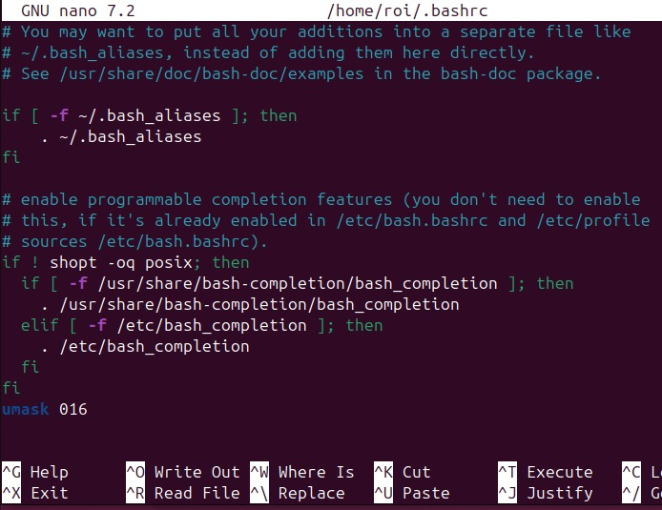

Scroll all the way down where you will find the **umask** value at the bottom of the file. When done editing press Ctrl + x, Y and then Enter.

**Verify:**

I created a new directory named "newdir" and checked its permissions, rwxrw---x has been applied to the directory by default.

Another way to verify is to check manually by typing  
*'sudo nano ~/.bashrc'*.

Or you can simply type umask and see the correct UMASK value which is **016**.

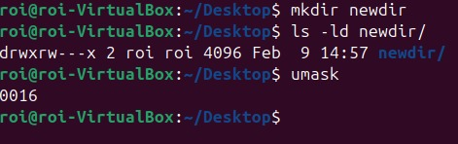 **Skills learned:** *echo, >>, ~/.bashrc, source, umask, ls -ld,* "permissions values"

**Task 4: Create the following groups:**

1. Group T, and add the user user1 to it.

2. Group users, add both user1 and user2 to it

**Creating Group T:**

Insert the command;   
*'sudo groupadd T'*

*'sudo usermod -aG user1'*

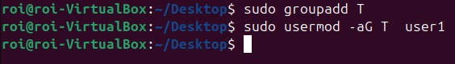

* *'Sudo groupadd <group_name>'* This command creates the group.
* *'Sudo usermod -aG <group_name> <username>'*.  
  -aG are two combined flags, **-a** adds a user to a group without removing him from other groups.  
  **G T** specifies the group to add the user to.

I asked the system to create group T, and then add user1 to group T.

**Creating group Users:**

**Create command*:*** *'sudo groupadd users'*

**Add user1 and user2:** *'sudo usermod -aG users user1 && sudo usermod -aG users user2'.*

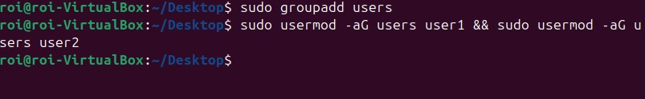

Same commands as before.

**Verify the groups exist:**

* *'getent group T'*
* *'getent group users'*

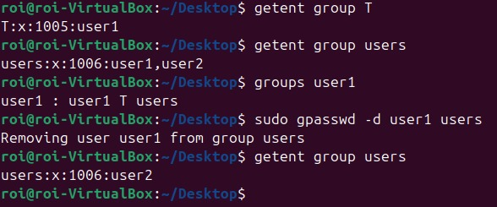

**getent** is used to query system databases like groups, users, and passwords from /etc/passwd, /etc/group, etc.

This command both confirms the existence of the groups and the presence of the users within them.

**Another method** is typing *'groups <username>'*, this will display all the groups the user is in.

I noticed user1 was in both group T and group users, I removed user1 from the group users by typing *'sudo gpasswd -d user1 users'*.  
this command deletes the specified user from the specified group.

And one last command you should know, groupdel to remove groups, *'sudo groupdel <group_name>'.*

**Skills learned:** groupadd, groupdel, gpasswd, groups, getent.

**Task 5 - file and group permissions:**

* Log in as user1 and create a file in the home directory named miko.txt.
* Set permissions for the file using octal values with the following rules:  
  Owner: Read & Write (RW)  
  Group (users): Read-only (R)  
  Others: Execute (X)

When you log into user1 and try to create a file you'll find out that user1 does not have permissions in its home folder.

First, we must find the home folder of our user.

I typed *'grep user1 /etc/passwd'*. The path to user1's home folder is **/users/user1**.



The owner of the directory /users/user1 is me **(root).**  
the command: *'sudo chown user1:user1 /users/user1'*, grants ownership to user1 over its home folder

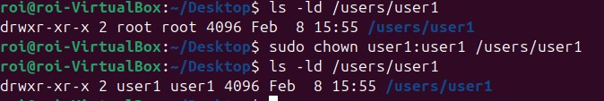  
I typed *'ls -ld /users/user1'* to **verify** the change.

Chown (change owner) is used to change the ownership of a file or directory.

The syntax is: *'sudo chown [owner]:[group] [file/directory]*'

**Create miko.txt:**  
*'su - <username>*' is a signup command, I signed into user1, make sure you are on your home directory (pwd) and type *'touch miko.txt'***.** type ls to confirm the file has been created successfully within the home directory.

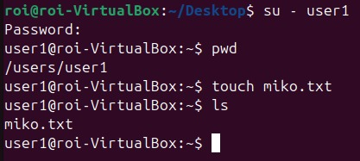

**I then set the following permissions to my text file:**

* Owner: Read & Write (RW) (4+2+0 = 6)
* Group (users): Read-only (R) (4+0+0 = 4)
* Others: Execute (X) (0+0+1 = 1)

The value of the permission is 641, *'chmod 641 miko.txt.'*

Run the command ls -l to **check**.

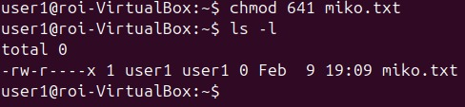

**Task 6 – Group database**

* Create the user "user4".
* Add "user4" to the "T" and "USERS" groups.
* Display the groups that "user4" is a member of.
* Display which groups have been created and their members.

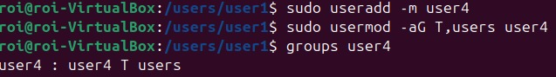

**Creates user4**

**Adds user4 to both T and users group.**

**groups user4** displays the groups user4 is in.

**Display which groups have been created and their members:**

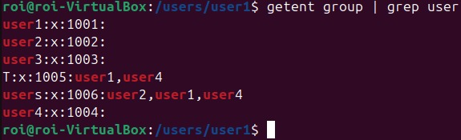

*'Getent group'* retrieves group information from the system’s group database.   
Piping the output to *'grep user'* filters for entries containing 'user,' displaying all relevant data related to groups with 'user' in their name or members."

**Bonus – create a user in a specified bath:**

Here is a command where we can create a user and specify its home folder.



*'sudo useradd -d <specified_path> <username>'.*

The -d flag specifies the user's **home directory**, instructing the system to set it to the given path.



'grep user5 /etc/passwd' extracts lines with the word **user5** from the file **/etc/passwd,** this proves to use that the user has been created in the right directory.

**Task 7:** **Write a** **script** **that copies the following files to the "documents" directory:**

* /etc/passwd
* /etc/group
* /etc/network/interfaces

First I found the document directory under "~" via 'ls', I then moved to the Documents directory by typing   
*'cd ~/Documents'* notice that Linux is case-sensitive! 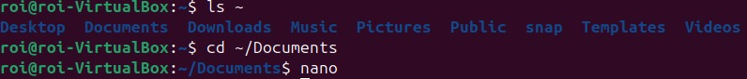

We are now inside the Documents directory, and I will create my script there. *'nano <filename>.sh'*.

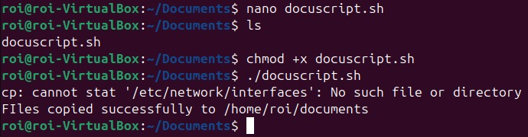

Check if the script is in the directory with the right permissions by *'ls -l <path>'*:

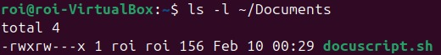

**The script**:

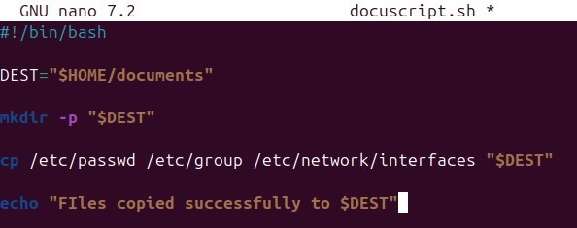

Start with **Shebang** **(#!/bin/bash).**

**DEST="$HOME/documents":** This sets the **variable** **DEST** to the path of the documents directory in your home folder.

* **$HOME":** Refers to the **home directory** of the current user.
* **documents:** The target directory where the files will be copied to.

**mkdir -p "$DEST"**:

* **-p:** This option is an assurance that if the directory doesn't exist it will be created with no errors.

**cp:** copies all 3 files to the requested directory.  
they will be copied to the specified "$DEST" (destination).

**Echo:** a nice message that let you know the files have been copied.

**Run the script:**



*'chmod +x docuscript.sh'* will add execution permission to the script.

*'./docuscript.sh'* This runs the script, the files are copied **successfully** except for **"/etc/network/interfaces".**



Why did I use variables instead of using a simple copy command?

* The variable $DEST offers more flexibility, changing the copy destination only requires changing the $DEST variable.
* Using variables also helps with reusability, meaning you can run the script from other users and it will automatically copy to **their** home folder.

**Task 8 – File management:**

Log in to the system as **user1** and perform the following actions:

* Create 10 text files named miko1 to miko10.
* Add the text "miko is the best" inside each file.
* Display all the files by name.
* Sort the files in order by their third column.
* Display the contents of the first column
* Print all the filenames you created into a file named files.txt.

**Create 10 text files:**

I first signed up as user1 *'su – user1'*. In **task 5**we gave user1 ownership over his home folder.

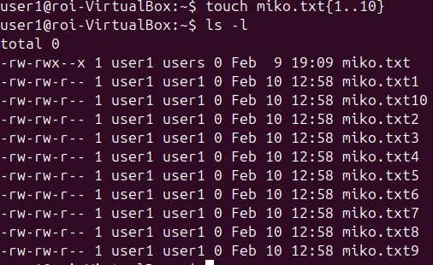

The command 'touch miko.txt{1..10}' is a single command that creates 10 files, inside the curly brackets I typed the number of files i want, {1..10} meaning {1 **to** 10}, we can always type a list of numbers of our choosing like this:

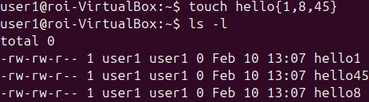

I can also delete several files using the same curly brackets method: *'rm miko.txt{1..5}'*.

**Add the text "miko is the best" inside each file:**

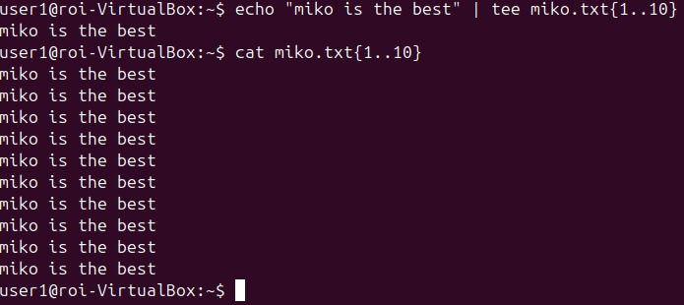

*'echo "miko is the best"*': Outputs the text "miko is the best".

*'tee miko.txt{1..10}':* Writes the output to all 10 files.

**tee** command in Linux is like a "T-junction" for data. It takes input from one source (like echo or a file) and **splits it into two directions,** in this case, it splits the data to 10 different directions, and is the simplest method to use when inserting text into multiple files.

I then ran the command 'cat miko.txt{1..10}' to display each file's contents.

**Sort the files by their third column:**

I started by editing one of our 'miko' files by typing 'nano <file_name>'.

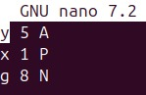inside of the file I made 3 columns, lower-case letter, number, upper-case letter.

Sort command: *'sort -k3 miko.txt'* this command will display the **third column** in ascending order.

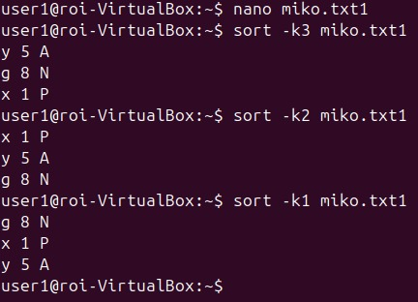

-k and the number after it determine which column to sort by.

**Sort 2 files:**

**'Sort -k<column> <file_name> <file_name>'**

**Sort in reversed order, add '-r' before '-k' for reverse**.

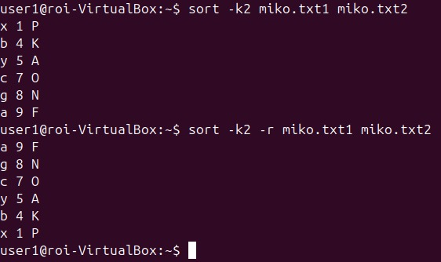

Sort multiple columns by typing *'sort -k1,1 -k2,2 -k3,3 miko.txt2'* and so on, in this example, I sorted columns 1 and 3:

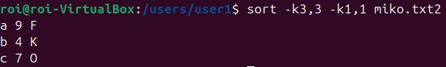

For sorting in a numerical order try adding 'n' after the column number, for example, *'-k,2,2n'*.

**Display the contents of a certain column:**

There are 2 methods to display the contents from a column:

Method 1: *'awk '{print $1}' miko.txt2'*

* **awk** is a powerful text-processing tool in Linux that allows you to extract data from files or input streams.
* **{print $1}':** Tells awk to print only the first column ($1) of each line in miko.txt2.

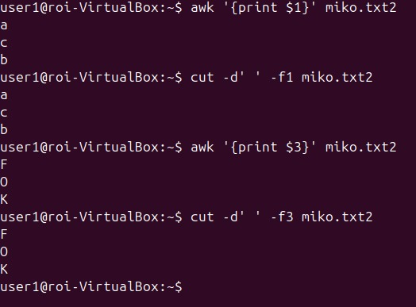

Method 2: *'cut -d' ' -f1 miko.txt2'*

This method is less robust than awk but still gets the job done.

-d' ' sets the delimiter for cut to a space, so it splits the input into columns based on spaces. (-f = column number)

**Print all the filenames you created into a file named files.txt.**

* I echoed all miko file names (1..10) to (>) this new text file (files.txt).
* Cat files.txt displays the contents of our new text file.

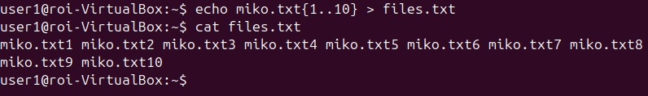

**Ready to take it a step further?** Let's use the commands we have learned so far and chain them using | (pipe).

Here is a little task of my own: extract **only** the word user from the /etc/passwd file and sort them in reverse order.

/etc/passwd looks something like this:

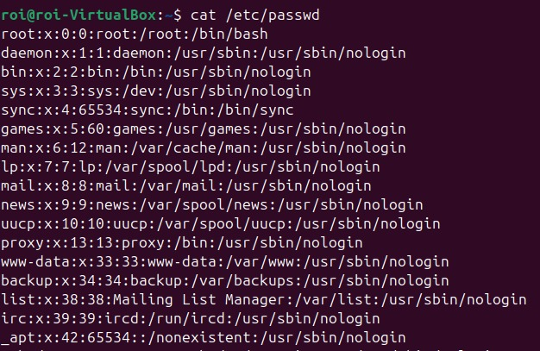  
And so on...

To do this I used 4 commands and piped them to each other, first I needed to get the output using *'cat /etc/passwd*', I then piped the output to cut, I basically told the system to start reading from the **first column** and **cut** the rest of the line when there's **":"** (marked by -d diameter).

I will still get a lot of lines tho shorter, to narrow our search some more I piped the output (after cut) to the grep command and filtered the word 'user'.

only the users are **displayed** without extra fluff. 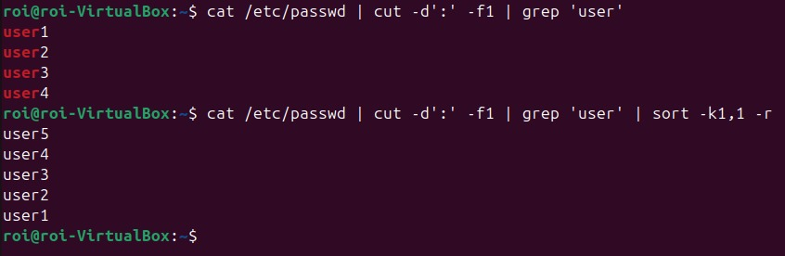

Lastly, I piped the output to the sort command, told it to sort in reverse order (-r) and here are the results:

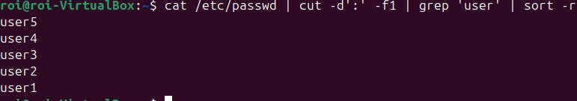

**Skills learned:** awk, cut, sort, rm, tee, ..

**Task 9 – Display the files inside of /etc without subdirectories:**

* Sort by date
* Sort by size
* Sort by descending order
* Save the output into a file name "etcfiles.txt"

Display /etc files:

In order to display directories only with no subdirectories I will use the command '-maxdepth 1' to dictate how deep should the find command go, 1 means don't go any deeper than directories.

-type f ensures that only **regular files** are included in the search results.

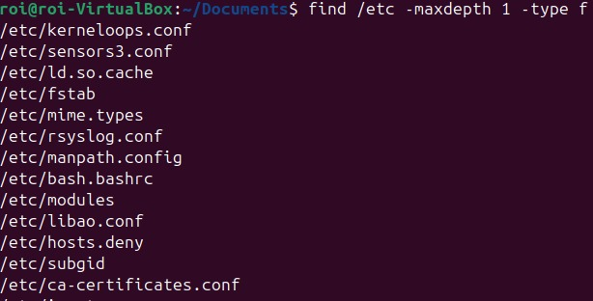

**Sort by date and size:**

Modify the existing command to:

* *'find /etc -maxdepth 1 -type f | xargs ls -lt'*.
* I have now piped the output to xargs who's role is to take the input from a command (like find) and **pass it as arguments** to another command like **ls**
* The flag added to ls '-lt' sorts by **date** from newest to oldest.
* 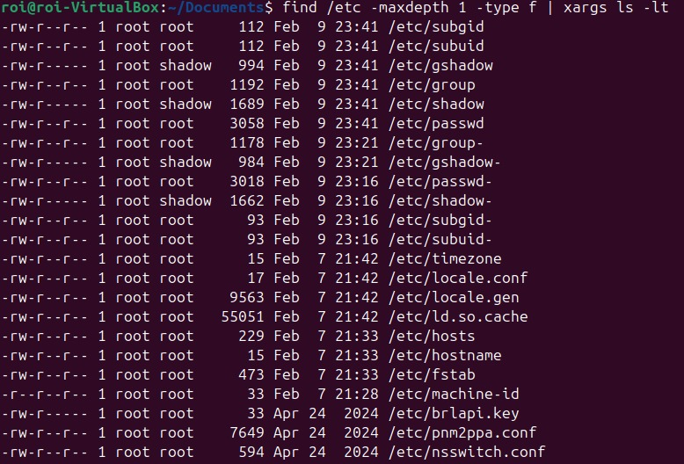The flag added to ls to sort **size** is ' lS ' (reminder that Linux is case sensitive!)

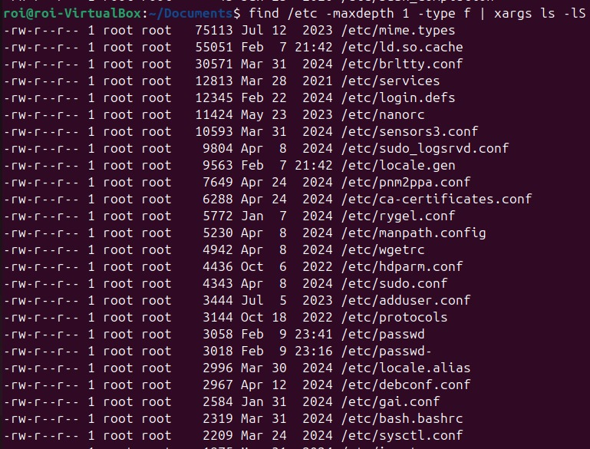

**Sort by descending order:**

add 'r' to the end of the flag for 'reverse', for example:

* **'ltr'** – oldest to newest.
* **'lSr'** – smallest to largest.

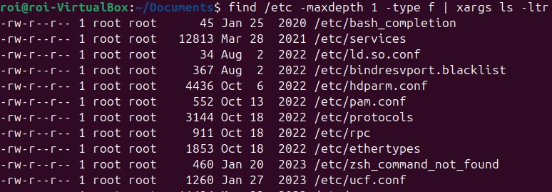

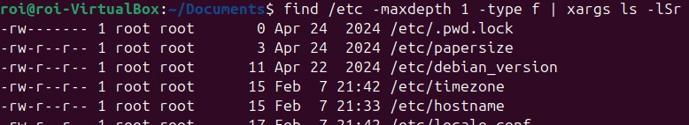

Save the output into a file name "etcfiles.txt"

I appended all of that output to a text file named etcfiles.txt using '>' and then used 'cat' to verify.

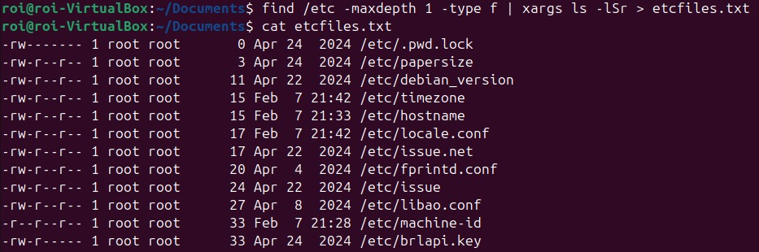

**Skills learned**: xargs, reverse flag, sort by time and size, maxdepth.

**Task 10: User and Shell Information Extraction**

* Display the file /etc/passwd
* Display only the first column and send the output to the file root.txt
* Save the file to Desktop
* Display the column containing the username of user2 and their shell partition, then send the output to the file user2.txt

**Display the first column, send the output to root.txt and save to Desktop:**

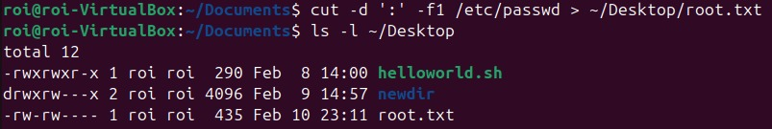

I used the cut command to extract the first column, specifying ':' as the delimiter to instruct the system to **split each line at** ':'.

-f1 tells cut to extract only the first field (column) from each line based on the specified delimiter.

I appended the output to a file named "root.txt" and specified the path to create it on the Desktop.

Confirmed the file's existance using *'ls -l <specified_path>'.*

Using cat ensures that the output was generated correctly and successfully written to the file.

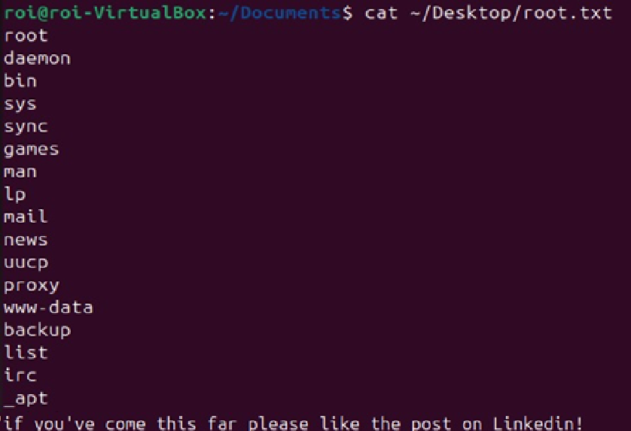

**Display the column containing the username of user2 and their shell partition, then send the output to the file user2.txt:**

First, we need to know where column the shell partition is in, simply count every word separated by ':', until we count the **seventh** which is bin/bash.

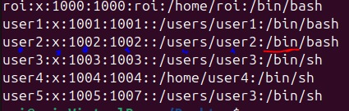



Why "^user2:"?

**^** ensures the match occurs at the beginning of the line.

Without **'^'** it would find any line that contains "user2", not just at the start.

-f1,7 instructs the system to extract from column 1 and 7. (7 is where shell is located as we discovered prior)

Used > to append the output to text and confirmed with cat.

**Task 11 – Symbolic Links**

A symbolic link (soft link) in Linux is a **shortcut** that points to another file or directory.   
It acts as a reference, allowing access to the file without duplicating its contents.

* Create a soft link of /etc/passwd.
* Pass it onto a file named pass.txt.
* create a file named "user2.txt" and insert the text "hi miko" into it.
* Create a hard link for "user2.txt" and name it "user3.txt"

**Create a soft link of /etc/passwd and pass it to pass.txt**



This command creates a symbolic link (pass.txt) in your home directory (~/) that **points** to /etc/passwd.

*'ln'* creates a **link** between the files, and *'-s'* specifies that the link should be **symbolic** (soft link).

I then used *'ls -l ~'* to search for directories in the home directory.

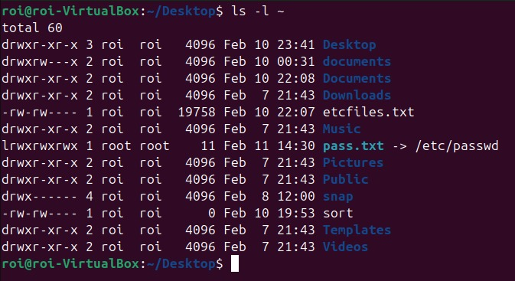

Symbolic links will be colored **light blue** and have a pointer (->) that points to the original file they reference.

create a file named "user2.txt" and insert the text "hi miko" into it.

**Create a hard link for "user2.txt" and name it "user3.txt".**

A hard link is a twin of the original file, pointing to the same data on disk.   
Even if you delete the original, the hard link remains.



This time I created a link without specifying it as a soft link with -s.

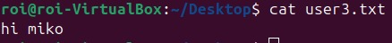

**Task 12 -** **Files Cleanup**

* Find all the files in the /tmp directory older than 3 days from the current date and delete them.
* Find all files with the 'txt' extension of all users and copy them to the 'tmp' directory.

**Find all the files in the /tmp directory older than 3 days from the current date and delete them.**

I used the find command on the /tmp **directory**, then used **- type f** - Filters files only.

**-mtime +3** Finds files modified more than 3 days ago.

**-exec** is a command used with 'find' to execute a specified command on each file that matches the search criteria.

I then executed the command **'rm'** to remove the files found in the search criteria.

**{}** present the files found by the find command

**\;** finishes off -exec.

**Find all files with the 'txt' extension of all users and copy them to the 'tmp' directory.**

**-name "*.txt"** means "match any file name that ends with .txt".

Then to copy the search results I used -**exec cp** to copy each found file to the **/tmp directory**.

**Verify:**

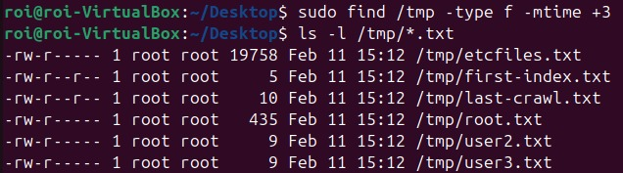

I used ls -l to display the contents of the tmp directory and the files that begin with txt ("*txt") that i have copied.

**Task 13: Installing packages**

* Upgrade and update the system with a single command.
* Install the programs: "git, ssh, Wireshark".
* Remove Wireshark including its dependencies.
* Download nmap without installing

**Upgrade and update the system with a single command:**

**sudo apt update** – Updates the package list.

**sudo apt upgrade** **-y:** Upgrades all installed packages to their latest versions (-y automatically answers "yes" to prompts).



**Install the programs: "git, ssh, Wireshark":**



Installing programs are just as easy as upgrading and updating, *'apt install <program name> -y'* will start the installation.

Use **dpkg** to confirm all programs have been installed successfully.

**dpkg** **-l** lists the installation status of the specified packages. (Ctrl + x to exit)

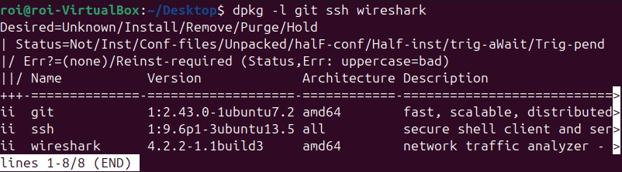

**Remove Wireshark including its dependencies:**

Dependencies are additional libraries or packages that a program **needs** to function properly.   
installing software on Linux also means that the required dependencies are also downloaded and installed.

Thus we want to remove a file without leaving useless files behind.



**Apt remove** – why remove and not rm? remove deletes applications while rm deletes files and directories.

**-- purge** makes sure to remove the **configuration files** as well.

**Download nmap without installing:**



Apt download – downloads the installation for the package, but the package is not installed yet.

**Make sure its downloaded:**



Install the package through the terminal by typing  
'sudo apt update' to update our repositories before installing.



Apt install – installs existing packages.

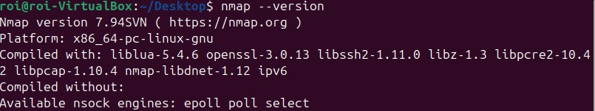

nmap --version will both check if nmap is working and also display its **version**.

**Task 14: Network configurations.**

* Configure a static IP
* Configure 2 DNS addresses, 8.8.8.8, 1.1.1.1.
* Log in via 'Putty' and show a working connection.

To get a general understanding of Networking and IP addresses, I'd like to refer you to my [**Network guide on Linkedin (Hebrew)**](https://www.linkedin.com/posts/roi-bokobza-1163b0314_the-world-of-networking-hebrew-activity-7228068760887185408-6kFO?utm_source=share&utm_medium=member_desktop)**.**

**Configure a static IP:**

Before configuring the network, go to /etc/netplan. *'cd /etc/netplan'*, type *'ls*', and there you'll find the **network configuration file** we have to configure.   
before editing the configuration file type *'ip a'* to see the current details of your network.

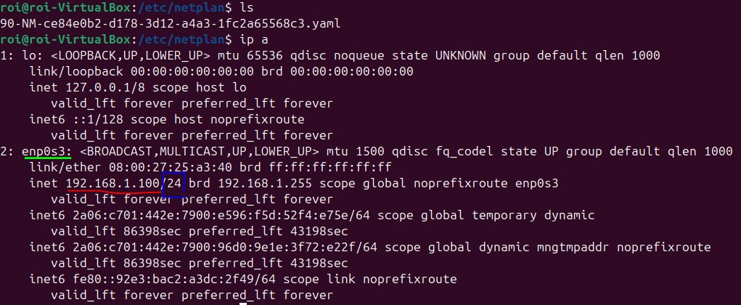

We'll have to remember our **name identifier (enp0s3).**

Ipv4 address **(192.168.1.100)** and subnet **( /24 )** so we'll know what to modify.

*'sudo nano <network-file-name>'*

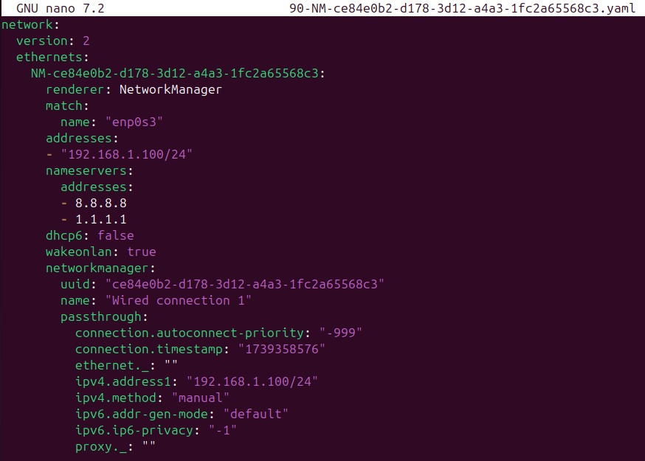

Now modify the file and change the appropriate **details** listed on the prior page to what I am showing here.

Make sure both the name and addresses present the correct details, and insert your static IP to "addresses".

Addresses list both DNS IP's (8.8.8.8 and 1.1.1.1)

Set dhcp6 or 4 **to false** toinsure that the automatic assignment of an IP address by the DHCP server, ensures the system uses a static IP address instead.

Set ipv4 to your static IP address.

*This file could be different on some systems and not always display the same things or be called the same names.

**Log in via 'Putty' and show a working connection:**

PuTTY is a free SSH and telnet client for remote access to servers, supporting secure connections, and file transfers.

For this part, nothing I did seemed to work, whether its disabling the firewall on both the VM and the physical machine, enabling ssh, changing the VM to bridged network, or trying to ping from PowerShell.

Seems like no matter what I tried the packets couldn't reach the host, like it wasn't on the same network.



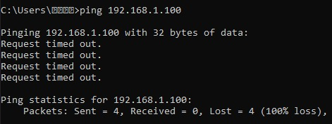

**Task15 – Multiple file creations**

* Create a directory named "globing" on Desktop.
* Create 20 sequentially numbered files within a directory using a single command.
* Create 20 files in the directory with the name 'miko' and an ascending a-b-c order using a single command.

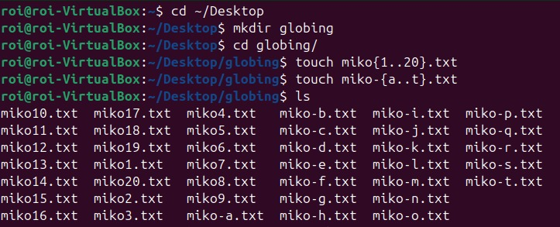

Created the directory "globing" under the path ~/Desktop.

Then used cd to access the globing directory and created the files inside it.

I used curly brackets to specify how I want the txt files to be numbered ({1..20} meaning 1 to 20).

I then did the same with the letters, a to t {a..t}.

I used ls to display the results.

**Task 15 Part 2:**

* Display files with names containing the numbers 5-9 using the globing search method.
* Display files with names containing the name miko and the letters "h" and "l" using the globing search method.
* Display all files that start with the letter "Z".

This command uses [5-9] to match any files containing the numbers 5 through 9 anywhere in the filename.



*\*miko-{h,l}*:* Matches files with miko-h or miko-l in their names.

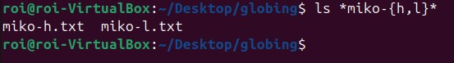

Z*: Matches any file name that starts with "Z". in this case there is no file name that starts with Z.



**Task 16: Extracting text**

* Print the output of the 'ip a' command into a file named net.txt
* Display how many lines, letters and words exist in the file
* Extract the MAC address from the output and save it in a file named mac.txt:
* Extract all IP addresses from the existing file and store them in ip.txt.

**Print the output of the 'ip a' command into a file named net.txt:**

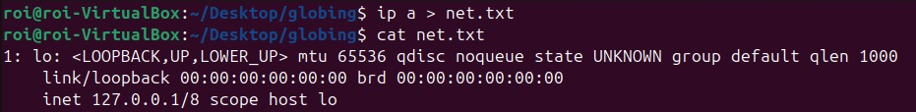

**Display how many lines, letters and words exist in the file:**



Wc counts and displays the number of lines, words, and characters in the net.txt file. In my net.txt file there are 12 lines, 72 words, and 702 letters.

**Extract the MAC address from the output and save it in a file named mac.txt:**

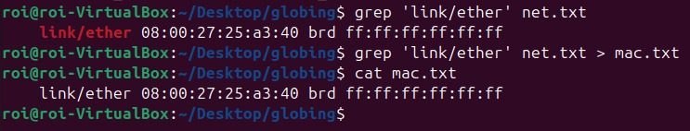

*'ip a | grep 'link/ether' > mac.txt'*

This searches net.txt for lines containing 'link/ether' (which includes the MAC address) and saves them to mac.txt.

**Extract all IP addresses from the existing file and store them in ip.txt.**

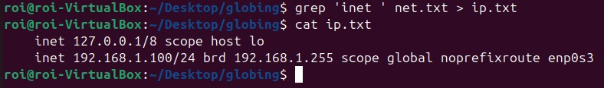

*'grep 'inet ' net.txt > ip.txt'* The command searches for linesin net.txt containing inet (IPv4 addresses) and saves them to ip.txt.

*note the space in inet ('inet ') we want to avoid matching with inet6 so we'll tell the system to only look for the string "inet".

This project was a solid dive into Linux and Bash, touching the basics like managing directories, users, and permissions, along with some scripting and networking. We got hands-on with tasks like creating groups, sorting files, and even downloading packages, which really helped me get comfortable with the command line. Overall, it’s been a good mix of theory and practice, and I feel way more confident working in Linux now!

See you at the next project!



Roi Bokobza